

**Green University of Bangladesh**

**Department of Computer Science and Engineering(CSE)**

**Faculty of Sciences and Engineering**

**Semester: (Summer, Year:2022), B.Sc. in CSE (Day)**

**LAB REPORT NO :09**

**Course Title:**  **Structured Programming Lab**

**Course Code: CSE 104 Section: DE**

**Student Details**

|  |  |
| --- | --- |
| **Name** | **ID** |
| **Md. Israil Fakir** | **221902125** |

**Submission Date : 11-Sep-22**

**Course Teacher’s Name : Md. Parvez Hossain**

**[For Teachers use only: Don’t Write Anything inside this box]**

|  |
| --- |
| **Lab Report Status**  **Marks: ………………………………… Signature:.....................**  **Comments:.............................................. Date:..............................** |

**Problem 01: Write a C program to check a number is positive or negative.**

**Code:**

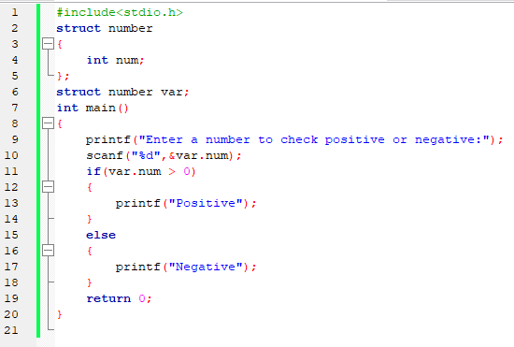

**Output:**

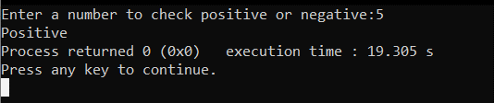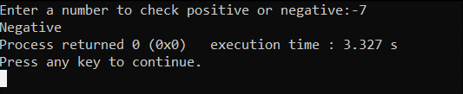

**Problem 02: Write a C program for input N numbers in array and print the summation of all value in array.**

**Code:**

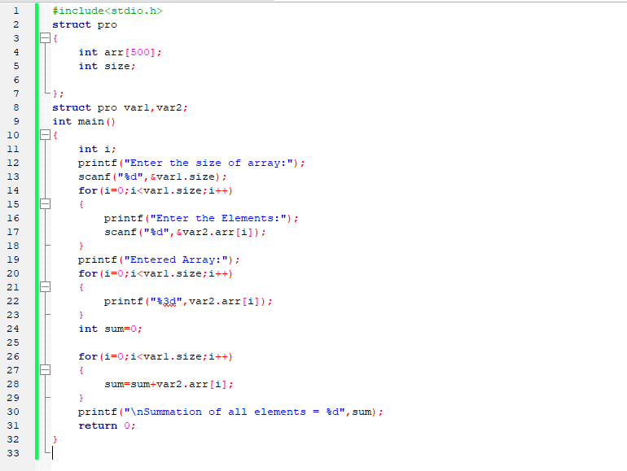

**Output:**

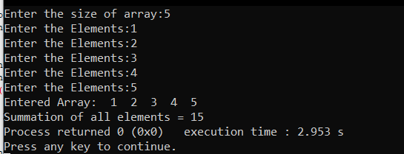

**Problem 03: Write a C program to calculate Celsius to Fahrenheit.**

**Code:**

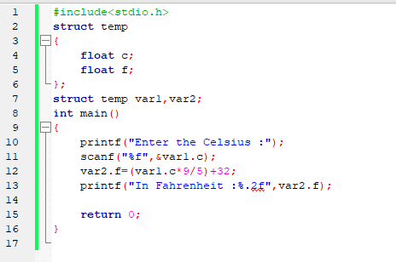

**Output:**

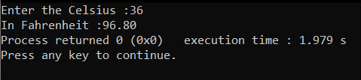

**Problem 04: Write a C Program to take input N size array and print reverse array.**

**Code:**

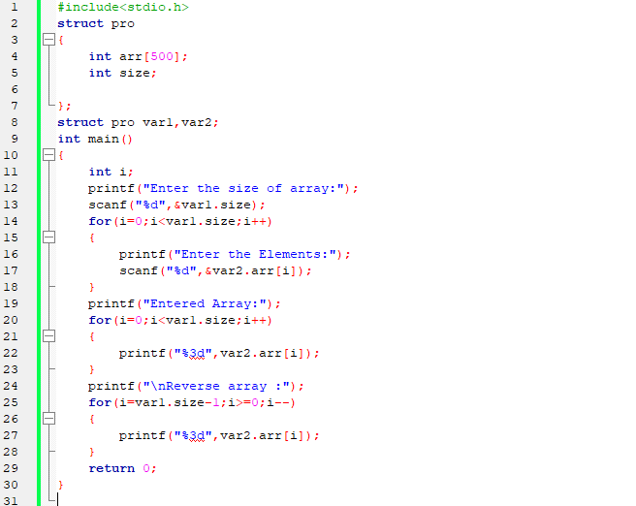

**Output:**

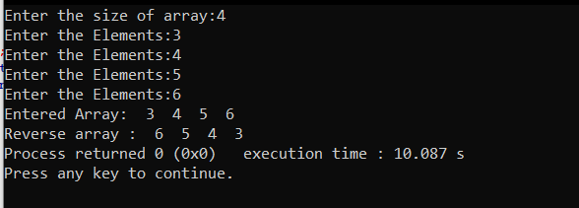

**Problem 05: Write a C program to check a character is vowel or consonant.**

**Code:**

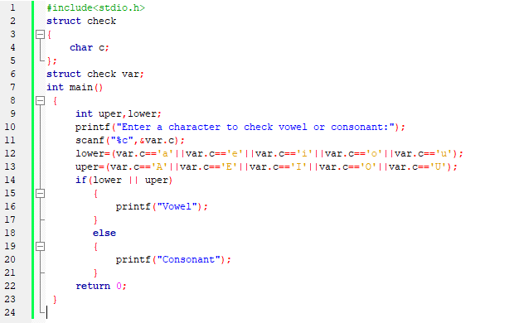

**Output:**

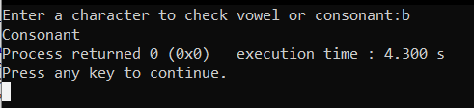

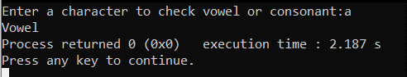

**Problem 06: Write a C program using nested structure to print your name and address with location.**

**Code:**

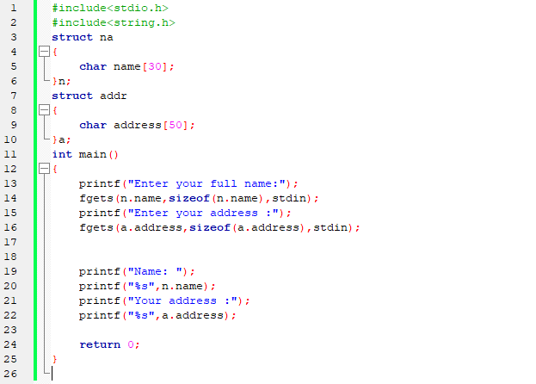

**Output:**

